MOLAO SECONDARY SCHOOL  CLASS: 7….  NAME: ………………………… | REVISION ENGLISH 7

UNIT 7: TRAFFIC
A. GRAMMAR - NGỮ PHÁP
I. IT INDICATING DISTANCE – It dùng để chỉ khoảng cách
1. Cấu trúc
Câu khẳng định | It + is + (about) + (a number) + unit of length + (from N_{place} to N_{place})  It + is + adj_{distance}
Câu phủ định | It + isn’t + adj_{distance}
Câu hỏi | How far is it from N_{place} to N_{place}?

2. Cách dùng
Chúng ta có thể sử dụng it như một Chủ ngữ để chỉ khoảng cách từ một địa điểm này đến một địa điểm khác.
Ví dụ:
- It is about 10 kilometers from my house to my school. (Nhà tôi cách trường tôi khoảng 10 km.)
- How far is it from your home to your office? (Khoảng cách từ nhà bạn đến trường là bao xa?)
It is (about) 1500 meters. (Nó khoảng 1500 m.)
- How far is it from Ho Chi Minh City to Vung Tau? (Thành phố Hồ Chí Minh cách Vũng Tàu bao xa?)
It is not very far. (Không xa lắm)
3. Dấu hiệu nhận biết
Trong câu thường có một số đi kèm một đơn vị chỉ độ dài: a kilometer, 1000 meters, 500 miles, ...
Trong câu thường có tính từ chỉ khoảng cách: far, near,...
II. USED TO - Đã từng
1. Cấu trúc
Câu khẳng định | S + use to + V
Câu phủ định | S + didn't + use to + V
Câu hỏi | Did + S + use to + V?

2. Cách dùng chính
- Dùng để diễn tả một hành động đã từng được thực hiện trong quá khứ và đã chấm dứt.
Ví dụ:
- I used to play basketball, but now I like playing video games. (Tôi đã từng chơi bóng rổ, nhưng bây giò tôi thích chơi điện tử.)
- He used to be a soccer player. (Anh ấy từng là một cầu thủ bóng đá - Chủ thể của hành động trên ở thời điểm hiện tại không còn là một cầu thủ bóng đá nữa.)
- Diễn tả một sự việc chưa từng xảy ra trong quá khứ.
Ví dụ:
- They didn't use to be best friends. (Họ chưa từng là bạn than của nhau - Hành động là bạn thân của nhau chưa từng xảy ra trong quá khứ, tuy nhiên chưa chắc đã không xảy ra trong hiện tại hoặc tương lai.)
- My father didn't use to buy a mobile phone for me, but in the future he will. (Bố của tôi chưa tùng mua cho tôi một chiếc di động nào cả, tuy nhiên trong tương lai có thể ông sẽ mua cho tôi.)
3. Dấu hiệu nhận biết
Trong câu thường có các động từ: used to, use to, didn't use to.
4. Lưu ý
- Trong câu hỏi hoặc trong câu phủ định, chữ "d" trong từ "used" sẽ bị bỏ đi.
Ví dụ:
- Did you used to play table tennis when you were a child? (Cậu đã từng chơi bóng bàn khi còn nhỏ chưa?)
- Did you used to walk to school? (Cậu đã từng đi bộ đến trường chưa?)
No, I didn't. I only went to school by car. (Không, tôi chỉ đến trường bằng ôtô.)
- I didn't used to play table tennis when I was a child. I used to play soccer and go swimming. (Tôi chưa từng chơi bóng bàn khi còn nhỏ. Tôi từng chơi bóng đá và đi bơi.)
- He didn't used to be a good student, but now he has a good job and can earn a lot of money. (Anh ấy chưa từng là một học sinh giỏi, nhưng bây giờ anh ấy tìm được một công việc tốt và có thể kiếm được rất nhiều tiền.)
B. VOCABULARY - TỪ VỰNG
Từ mới | Phiên âm | Nghĩa
cross | /krɒs/ | băng qua, vượt
curve | /kəːv/ | khúc cua
emergency | /iˈməːdʒ(ə)nsi/ | khẩn cấp
hill | /hɪl/ | đồi
lane | /leɪn/ | làn đường
left | /lɛft/ | trái
limit | /ˈlɪmɪt/ | giới hạn
pedestrian | /pəˈdestriən/ | người đi bộ
railroad | /ˈreɪlrəʊd/ | đường ray
right | /raɪt/ | phải
sjgn | /saɪn/ | biển hiệu
slippery | /ˈslɪp(ə)ri/ | trơn trượt
speed | /spiːd/ | tốc độ
traffic lights | /ˈtræfɪk laɪts/ | đèn giao thông
truck | /trʌk/ | xe tải
turn | /təːn/ | rẽ
vehicle | /ˈviː(ə)kl/ | phượng tiện
wet | /wɛt/ | ẩm, ướt

C. EXERCISES - BÀI TẬP THỰC HÀNH
PART 1. PHONETICS
1. Find the word which has a different sound in the part underlined. Read the words aloud.
1. A. wet B. met C. head D. hand
2. A. girl B. burn C. turn D. pearl
3. A. left B. debt C. fan D. dead
4. A. train B. tale C. mine D. rain
5. A. die B. bicycle C. high D. min
6. A. meet B. feed C. speed D. fit
7. A. limit B. lipid C. treat D. hit
8. A. curve B. term C. gear D. herm
9. A. truck B. drunk C. mug D. dark
10. A. sign B. light C. bye D. tin
2. Put the words with the underlined part in the box into two groups.
train young helicopter left
video plane rain tour
railway late southern does
station dead grey shoulder
head no wet road
/eɪ/ | /ɛ/

3. Label the signs with the words/phrases below.
Danger Railroad Crossing Right Lane Ends
No Trucks Right Turn Ahead
Right Curve Ahead Watch Children
Emergency Vehicle Warning No Pedestrian Crossing

a. | e.  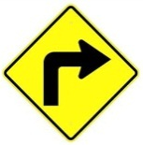
b.  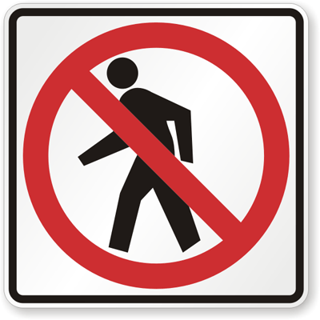 | f.  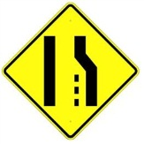
c.  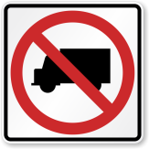 | g.
d. | h.  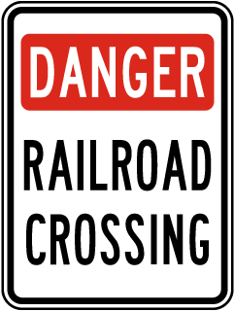
PART 2: VOCABULARY & GRAMMAR
1. Circle A, B, C or D for each picture.
1.  A. Maximum speed is 5.  B. Minimum speed is 5.  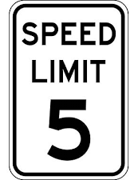  C. Only 5 MPH is allowed.  D. Speed limit is lower than 25 MPH. | 4.  A. You can buy cattle meat here.  B. There are cattle ahead.  C. There are wild animals ahead.  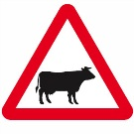  D. Cattle are not allowed.
2.  A. Cars cannot be sold here.  B. Cars and trucks can pass.  C. Cars are not allowed.  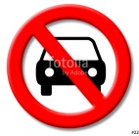  D. Bicycles are not allowed. | 5.  A. Bullying is allowed.  B. Bully may be arrested.  C. Bullying must be stopped.  D. This zone is dangerous.
3.  A. You cannot return.  B. Go ahead isn't allowed.  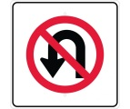  C. You must return.  D. Watch out the pedestrians. | 6.  A. Cameras are used here.  B. You can't use your camera here.  C. Cameras are sold ahead.  D. Take photograph when crossing road.
2. Find one odd word A, B, C or D.
1. A. train B. plane C. plant D. car
2. A. left B. right C. straight D. square
3. A. green B. red C. orange D. light
4. A. drive B. write C. ride D. fly
5. A. fast B. rapid C. slow D. quick
3. Put questions for the underlined parts in the following sentences, using question words in brackets.
1. Nam usually goes to school by bus. Sometimes, he rides his bicycle. (How)

2. My grandfather used to go fishing in the West Lake every afternoon. (What)

3. There are a lot of trucks and cars on the highway in the rush hour. (Where)

4. The students used to be taught about road signs when they studied in secondary school. (What)

5. Hung always drives his car very carefully. (How)

6. It is about 100 km from Ha Noi to Hai Phong. (How long)

4. Fill each blank with suitable words in the box.
am is are used to use to it from
to catches walked ride jam station
1. Mai driving her car to her office.
2. How far it from your home to your school?
3. You will get stuck in a traffic if you go outside in the rush hour?
4. He usually on foot to school when he was a child.
5. you in hurry?
6. Did you go swimming on the lake near your house, Tuan?
7. Lana comes USA. She was born in a well-known family.
8. My dad the bus to work every morning, but Mom drives.
9. John used to immigrate Brazil. Have you ever been there?
10. I participating in a volunteer trip to Lang Son. A lot of families are living in poor conditions.
11. is not very far from here to the warehouse.
12. I must go to railway to catch a train to my motherland.
5. Complete the following conversation with the sentences A-F.
Burt: Why didn't you show up for class this morning?
Kevin: I don't even want to talk about it. .
Burt: ?
Kevin: The engine seems to be busted. !
Burt: Wow. Have you thought about getting a new car?
Kevin: Yeah, I've thought about that, .
I'm broke.
Burt: Maybe you can lease a car. .
I know Toyota is running a promotion.
Kevin: Really? How much is it?
Burt : .
Kevin: That's a good deal. I might want to consider it.
A. My car broke down | D. It doesn't cost much
B. It's driving me crazy | E. but I can't afford a new car
C. Zero down and $219 per month | F. What happened

6. Give the correct form of the words in brackets.
Traffic jam (to be) a common sight in big cities like Delhi, Mumbai, Calcutta etc. This is due to (increase) population of the metropolitan cities. People from far off places rush towards big cities to (earn) as big cities (have) many options and possibilities for them. Then there are permanent citizens also. So with the human traffic, vehicular traffic also increases. As the standard of living is (become) high everyone wants to (purchase) his own car.
PART 3: READING
1. Fill in the blank with a word/ phrase in the box.
trains discourage transport expensive
example problem cities pollution
Traffic congestion in many (1) around the world is severe. One possible solution to this (2) is to impose heavy taxes on car drivers and use this money to make public transport better. One of the first benefits of such a measure is that the heavy taxes would (3) car owners from using their cars because it would become very (4) to drive. This would mean that they would begin to make use of public (5) instead, thus reducing traffic problems and (6) as well. Another benefit would be that much more use would be made of public transport if it was improved. It is often the case that public transport in cities is very poor. For (7) , we often see old buses and (8) that people would rather not use. High taxes would generate enough money to make the necessary changes.
2. Read the passage and answer the questions.
The first traffic control device appeared near the British House of Parliament at the intersection of George and Bridge Streets. The device was made in response to the desire by a Select Committee to use railway signals on highways. The device had lights and it used arms which extended outwards. It was operated manually by a police officer. The signal was 22 feet high and crowned with a gas light. The light was called semaphore and had arms that would extend horizontally that commanded drivers to "Stop" and then the arms would lower to a 45 degrees angle to tell drivers to proceed with "Caution". At night a red light would command "Stop" and a green light would mean use "Caution". The man behind this new and different invention was John Peake Knight a railroad engineer. The main reason for the traffic light was that there was an overflow of horse-drawn traffic over Westminster Bridge which forced thousands of pedestrians to walk next to the house of Parliament. But Knight's invention was not to last long. After only a month of use the device exploded and injured the police officer who was operating the light. In the first two decades of the 20th century semaphore traffic signals, like the one in London, were in use all over the United States with each state having its own design of the device. One good example was from Toledo, Ohio in 1908. The words "Stop" and "Go" were in white on a green background and the lights had red and green lenses illuminated by kerosene lamps for night travelers and the arms where eight feet above ground. Controlled by a traffic officer who would blow a whistle before changing the commands on this signal to help alert travelers of the change, the design was also used in Philadelphia and Detroit. The example in Ohio was the first time America tried to use a more visible form of traffic control that evolved the use of semaphore. The device that was used in Ohio was designed based on the use of railroad signals.
1. What was the main purpose of making the first traffic control device?

2. What was the light operated manually by a police officer called?

3. Why wasn't John Peake Knight's invention to last long?

4. How tall were the arms of the traffic lights used in Ohio in 1908?

5. The Westminster Bridge is in .
A. America B. England C. Brazil D. Canada
3. Read the passage and put a suitable word in each of the gaps.
Traffic jams in Vietnam only frequently take in Hanoi capital and Ho Chi Minh City. Vietnamese people seem to be accustomed to traffic congestion, even miss it whenever they go to other places. There is no fixed rule for the the traffic jams to happen but is worst during the rush hour when everyone is in a hurry to get to work or come back home. Apart from peak hours, the time between 9 am and 10 am and between 3 pm and 4 pm also witnesses long lines of vehicles, mainly motorbikes, struggling to get of narrow streets.
Whenever it rains, the traffic jam gets more terrible with the joining hand of flooding. Taxis are extremely hard to or wave during the downpour. However, it only about 30 minutes on average for a standstill and 2 hours to get through the worst, not really bad compared to that of other countries. While the rapid increase in car use coupled with the deterioration of roads caused by disordered planning make the matter worse, the most annoying thing about the traffic jam the way people react when being at the congestion. Most road users ride their motorbikes on the pavement rather than waiting calmly, or they constantly use their horns to hasten riders in the front, even shouting at them from time to time. More luckily, bicyclists can leisurely carry their "war-horses" on their backs and thread their way through messy matrixes.
PART 4: WRITING
1. Make sentences using the words and phrases given.
1. Mr Thanh/ didn't/ to/ travel/ Korea.

2. It/ 250 km/ Ho Chi Minh City/ Da Nang.

3. My hometown/ used to/ small village.

4. How/ it/ Ha Noi/ Singapore/ past?

5. Lana/ use to/ on foot/ school/ or/ car?

6. He/ used/ good/ student/ but/ now/ poor.

2. Rewrite the following sentences so that their meaning stays the same, using the word given for each.
1. My father is always a careful driver. | DRIVES
2. The distance from Ha Noi to Hai Phong is about 100 km. | IT
3. Be careful or you'll have an accident. | IF
4. Hung went to his homeland by train some years ago, but now he drives his car. | USED
5. Road users should obey traffic rules strictly. | OBEYED
6. Is it possible to travel to Korea by car? | CAN
7. Buses leave for Hai Phong every 15 minutes from 6 a.m to 10 p.m. | THERE
8. My family was very poor in the past, but we have 100 million USD now. | USED

UNIT 8: FILMS
A. GRAMMAR - NGỮ PHÁP
I. ALTHOUGH, DESPITE/ IN SPITE OF- Mặc dù
1. Cấu trúc
Câu khẳng định | - Although + Clause, Clause.  - Despite/ In spite of + N/ N phrase, Clause.
Câu phủ định | - Although + Clause (phủ định), Clause  Although + Clause, Clause (phủ định)  - Despite/ In spite of + N, Clause (phủ định)  Despite/ In spite of + N phrase, Clause (phủ định)  Despite/ In spite of+not + N phrase, Clause.

2. Cách dùng
Chúng ta sử dụng although, despite/ in spite of để diễn tả sự đối lập của hai sự việc hiện tượng trong cùng một câu.
Ví dụ:
- Although he is so young, he performs excellently. (Mặc dù anh ấy rất trẻ, nhưng anh ấy thể hiện rất xuất sắc - Có thể thấy mệnh đề 1 có sự đối lập với mệnh đề 2, tuổi tác trẻ đồng nghĩa với việc thiếu kinh nghiệm và có sự đối lập với việc thể hiện xuất sắc, yêu cầu nhiều kinh nghiệm.)
- Despite/ In spite of being so young, he performs excellently. (Mặc dù còn rất trẻ, nhưng anh ấy thể hiện rất xuất sắc - Có nghĩa tương tự như mệnh đề sử dụng Although, nhưng cấu trúc dạng despite/ in spite of chỉ đi với một cụm Danh từ đi ngay sau nó.)
- Despite/ In spite of his young age, he performs excellently. (Tương tự như trên, nhưng đi ngay sau despite/ in spite of là một Danh từ).
3. Dấu hiệu nhận biết
- Trong câu xuất hiện các trạng từ: although, though, even though, despite, in spite of...
- Trong câu chỉ xuất hiện phủ định ở một mệnh đề và không xuất hiện liên từ "but".
4. Lỗi thường hay gặp khi sử dụng cấu trúc although, despite/ in spite of
- Mặc dù có ý nghĩa giống nhau, nhưng cách sử dụng của although là khác so với despite/ in spite of. Chúng ta cần nhớ: ngay sau although (though/ even though) là một Clause, còn sau Despite/ In spite of thì bắt buộc phải là một N hoặc N phrase.
- Trong câu sử dụng cấu trúc although, despite/ in spite of không sử dụng liên từ but, cho dù dịch sang Tiếng Việt vẫn là Mặc dù..., nhưng...
II. HOWEVER, NEVERTHELESS - Tuy nhiên
1. Cấu trúc
- Clause 1. However/Nevertheless, Clause 2.
- Clause 1; however, Clause 2.
Ví dụ:
- I am good at English. However, I study Math so bad.
- She used to live in Ha Noi. Nevertheless, she is living in New York now.
2. Cách dùng chính
- Dùng để diễn tả hai câu có nội dung đối lập nhau.
Ví dụ:
- John used to be a bully. However, he is the most humorous and generous guy in my company now. (John từng là một kẻ chuyên đi bắt nạt người khác. Tuy nhiên, anh ta bây giờ là người vui tính và tốt bụng nhất trong công ty của tôi.)
- My family is poor. However, my parents always try to earn as much money as possible for my university education. (Gia đình của tôi là nghèo. Tuy nhiên, bố mẹ tối luôn cố gắng kiếm nhiều tiền nhất có thể để tôi có thể học đại học).
- My grandfather is a strict man. Nevertheless, he is the kindest person I have ever known. (Ông tôi là một ngưòi đàn ông nghiêm khắc. Tuy nhiên, ông là người tốt bụng nhất mà tôi từng biết đến.)
- I really love animals. Nevertheless, I only like raising loyal ones. (Tôi thực sự rất yêu quý động vật. Tuy nhiên tôi chỉ thích nuôi những con vật trung thành.)
3. Dấu hiệu nhận biết
- Trong câu xuất hiện các trạng từ sau: however, nevertheless ...
- Nghĩa của hai câu được đề cập là đối lập với nhau.
B. VOCABULARY - TỪ VỰNG
Từ mới | Phiên âm | Nghĩa
actor/ actress | /ˈæktə(r)/ /ˈæktrəs/ | diễn viên nam/ nữ
animation | /ˌænɪˈmeɪʃn/ | phim hoạt họa
critic | /ˈkrɪtɪk/ | bình phẩm
direct | /dʌɪˈrekt/ | làm đạo diễn (phim,...)
entertaining | /ˌentəˈteɪnɪŋ/ | thú vị, làm vừa lòng
gripping | /ˈɡrɪpɪŋ/ | hấp dẫn, thú vị
hilarious | /hɪˈleəriəs/ | vui nhộn, hài hước
horror film | /ˈhɒrə(r) fɪlm/ | phim kinh dị
must-see | /mʌst- siː/ | phim hấp dẫn cần xem
plot | /plɒt/ | cốt truyện
posters | /ˈpəʊstə(r)/ | áp phích quảng cáo
recommend | /ˌrekəˈmend/ | giới thiệu, tiến cử
scary | /ˈskeəri/ | làm sợ hãi, rung rợn
science-fiction (sci-fi) | /ˌsaɪəns ˈfɪkʃn/ | khoa học viễn tưởng
star | /stɑː(r)/ | đóng vai chính, ngôi sao
survey | /ˈsɜːveɪ/ | cuộc khảo sát
thriller | /ˈθrɪlə(r)/ | phim li kì, giật gân
violent | /ˈvaɪələnt/ | có nhiều cảnh bạo lực

C. EXERCISES - BÀI TẬP THỰC HÀNH
PART 1. PHONETICS
1. Find the word which has a different sound in the part underlined. Read the words aloud.
1. A. picked B. promised C. delivered D. clicked
2. A. long B. boring C. shocked D. comedy
3. A. jumped B. washed C. liked D. loved
4. A. thread B. bread C. beam D. breath
5. A. actor B. acting C. address D. action
6. A. other B. among C. potato D. nothing
7. A. thumb B. shoulder C. poultry D. slow
8. A. thorough B. tomato C. drunk D. bus
9. A. window B. drunk C. bowl D. grow
10. A. naked B. talked C. walked D. booked
2. Put the words with the underlined part in the box into three groups.
bushed washed stopped needed
volunteered touched matched tagged
moved fascinated shocked appeared
raised laughed convinced interested
treated pleased looked decided
/t/ | /d/ | /id/

3. Give the names of the following films then read the words aloud.
a.  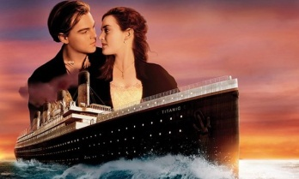 | e.  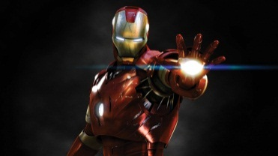
b.  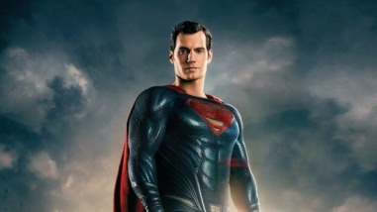 | f.  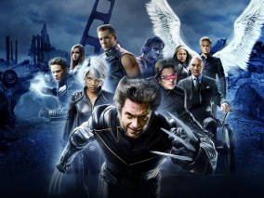
c.  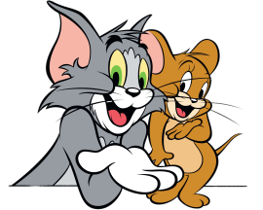 | g.  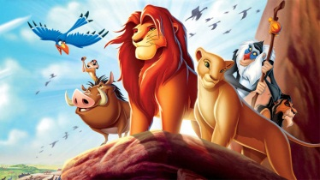
d.  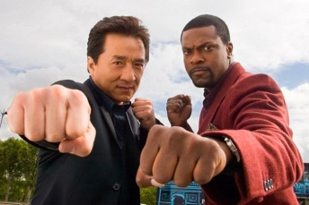 | h.  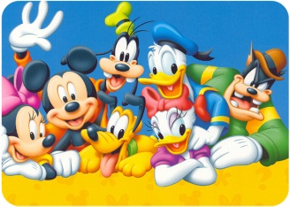
PART 2: VOCABULARY & GRAMMAR
1. Match the film titles and their plots (1-6) with the film types (a-h).
a. an animation b. a western c. a horror film d. a biopic
e. a romantic comedy f. an action film g. a sci-fi h. a thriller
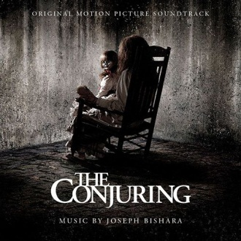  1. Paranormal investigators Ed and Lorraine Warren work to help a family terrorized by a dark presence in their farmhouse. | 4. The character first appeared in the daily King Features comic trip, Thimble Theatre, on January 17, 1929.
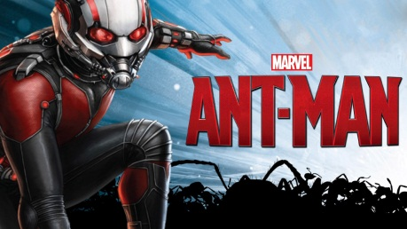  2. Armed with a super-suit with the astonishing ability to shrink in scale but increase in strength. | 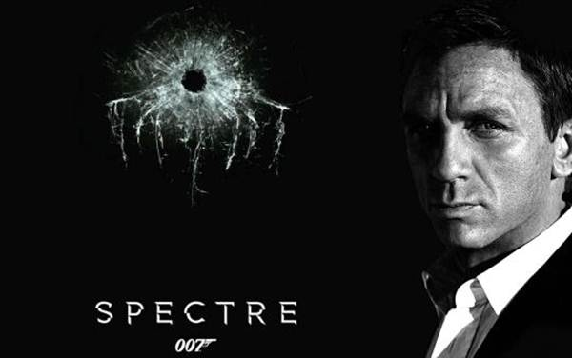  5. A cryptic message from Bond’s past sends him on a trail to uncover a sinister organization.
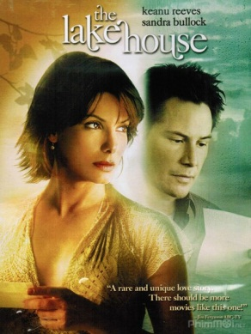  3. A lonely doctor who once occupied unusual lakeside home begins exchanging love letters with its former resident, a frustrated architect. | 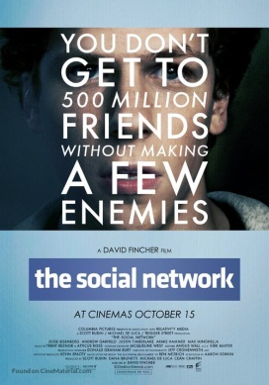  6. Harvard student Mark Zuckerberg creates the social networking site that would become known as Facebook, but is later sued by two brothers.

2. Find one odd word A, B, C or D.
1. A. terrifying B. thrilling C. fascinating D. delicious
2. A. fresh B. convincing C. believable D. interesting
3. A. excellent B. interesting C. amusing D. bad-tempered
4. A. fantastic B. wonderful C. brilliant D. lazy
5. A. dramatic B. funny C. beautiful D. boring
3. Complete the sentences with the correct form of the adjectives in brackets.
1. It's an film and I'm every time I start watching it. (interest)
2. It was in the lesson because our teacher is in history. (bore)
3. My father is very with my Math examination because of the mark. (amaze)
4. My friend is a very sort of person, but he hates doing activities. (relax)
5. Working all day is very . I get when I enter my factory. (tire)
6. We were all very about the school trip, but it wasn’t an trip at all. (excite)
4. Complete the sentences with the correct form of the adjectives in the box.
bore | excite | interest
tire | interest | bore

1. I wish this book weren't so ; I keep falling asleep whenever I try to read it.
2. "Do you think football is ?"- "Oh, I don't think so. I find table tennis is a most suitable sport for myself."
3. I'm right now. Last night I had a terrible nightmare?
4. The film was . Nothing happened.
5. Thomas was very about his new bicycle as a birthday present. He had woken up at 5 a.m. and rode the bicycle around the street.
6. This is a very book about the history of the cinema. I'm learning a lot.
5. Complete the sentences, using words in the table. Sometimes, two answers are possible.
although | despite | in spite of | however | nevertheless

1. it was raining heavily; he went out without a raincoat.
2. I heard the telephone ring, I didn't answer it.
3. I like the outdoors. , I don't like bugs and dirt.
4. her fear, she wrapped her arms around him.
5. The sky was grey and cloudy. , we went to the beach.
6. Nevertheless, many and serious shortcomings, the long series of Depretis administrations was marked by the adoption of some useful measures.
7. We have not yet won; , we shall keep trying.
8. And yet, her feelings, any relationship with him was potentially dangerous.
9. the issue was not discussed, it was far from out of her mind.
10. all Kutuzov's efforts to avoid that ruinous encounter, the massacre of the broken mob of French soldiers by worn-out Russians continued at Krasnoe for three days.
11. It looks like they're going to succeed their present difficulties.
12. being able to bench press two of her, the men actually listened.
13. she had said the words "I love you," several times, he had not uttered them.
14. Deidre felt no pity for him, the circumstances.
6. Choose best answer A, B, or C to complete the sentences.
1. It stars Marlon Brandon as the Godfather. He won an Oscar for his as the boss.
A. action B. performance C. direction
2. Shaun of the Dead is a . It's very funny, but it's also a horror film.
A. cartoon B. comedy C. sci-fi
3. There's The Princess and the Frog. It's an film from Disney.
A. ugly B. animated C. boring
4. The film was so boring. , Jack saw it from beginning to end.
A. Therefore B. However C. Although
5. If you want to know which films are on at the cinemas, you should look at the film of this newspaper.
A. section B. review C. report
6. I think I did OK in my speech last night I'd had almost no sleep for 24 hours.
A. Although B. However C. Despite
7. My film this year was Zero Game, the latest thriller by director Xi Dong.
A. hobby B. favorite C. love
8. I couldn't sleep, being tired.
A. However B. Though C. In spite of
PART 3: READING
1. Fill in the blank with a word/ phrase in the box.
romance shot used to essential
stars fictionalized voyage imaginary
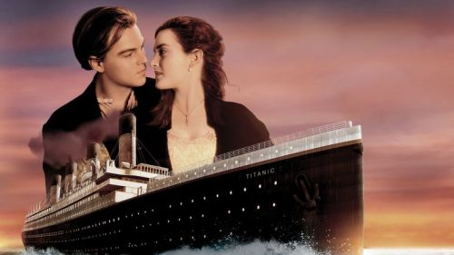
Titanic is a 1997 American epic (1) disaster film directed, written, co-produced, and co-edited by James Cameron. A (2) account of the sinking of the RMS Titanic, it (3) Leonardo DiCaprio and Kate Winslet as members of different social classes who fall in love aboard the ship during its ill-fated maiden (4) .
Cameron's inspiration for the film came from his fascination with shipwrecks; he felt a love story interspersed with the human loss would be (5) to convey the emotional impact of the disaster. Production began in 1995, when Cameron shot footage of the actual Titanic wreck. The modern scenes on the research vessel were (6) on board the Akademik Mstislav Keldysh, which Cameron had used as a base when filming the wreck. Scale models, computer-generated (7) , and a reconstruction of the Titanic built at Playas de Rosarito in Baja California were (8) re-create the sinking. The film was partially funded by Paramount Pictures and 20th Century Fox. It was the most expensive film made at that time, with an estimated budget of $200 million.
2. Read the passage and answer the questions.
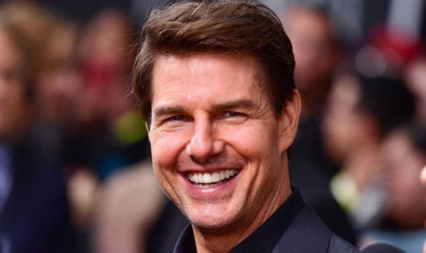
Tom Cruise (born Thomas Cruise Mapother IV; July 3, 1962) is an American actor and filmmaker. Cruise has been nominated for three Academy Awards and has won three Golden Globe Awards. He started his career at age 19 in the 1981 film Endless Love. After portraying supporting roles in Taps (1981) and The Outsiders (1983), his first leading role was in the romantic comedy Risky Business, released in August 1983.
Cruise became a full-fledged movie star after starring as Pete "Maverick" Mitchell in the action drama Top Gun (1986). One of the biggest movie stars in Hollywood, Cruise starred in several more successful films in the 1980s, including the dramas The Color of Money (1986), Cocktail (1988), Rain Man (1988), and Born on the Fourth of July (1989).
In the 1990s, he starred in a number of hit films, including the romance Far and Away (1992), the drama A Few Good Men (1992), the legal thriller The Firm (1993), the romantic horror film Interview with the Vampire: The Vampire Chronicles (1994), the romantic comedy-drama sports film Jerry Maguire (1996), the erotic thriller Eyes Wide Shut, and the drama Magnolia (both 1999). In 1996, Cruise was well known for his role as secret agent Ethan Hunt in the Mission: Impossible film series, whose most recent film, Mission: Impossible - Rogue Nation, was released in 2015.
1. What is the real name of Tom Cruise?

2. What was his first film as an actor?

3. What part did he play in Top Gun?

4. What is the type of Interview with the Vampire?

5. What is the latest film of Tom Cruise mentioned above?

3. Read the passage and put a suitable word in each of the gaps.
The advent of cinema in the late 19th (1) , and later radio and television in the 20th century broadened the access of comedians to the general public. Charlie Chaplin, through (2) film, became one of the best known faces over the (3) . The silent tradition lived on well into the 20th century through my artists like Marcel Marceau, and the physical comedy artists (4) Rowan Atkinson as Mr. Bean. The tradition of the circus clown also continued, with such as Bozo the Clown in the United States and Oleg Popov in Russia.
Radio provided new possibilities - with Britain producing the influential Goon Show after the Second World War. American cinema has produced a great (5) of globally renowned comedy artists, from Laurel and Hardy, the Three Stooges, Abbott and Costello, Dean Martin and Jerry Lewis, as well as Bob Hope during the mid-20th century, to performers like George Carlin, Robin Williams, and Eddie Murphy at the (6) of the century. Hollywood attracted many international talents like the British comics Peter Sellers, Dudley Moore and Sacha Baron Cohen, Canadian comics Dan Aykroyd, Jim Carrey, and Mike Myers, and the Australian comedian Paul Hogan, (7) for Crocodile Dundee. Other centers of creative comic activity have been the cinema of Hong Kong, Bollywood, and French farce.
American television has also been an influential force in world comedy: with American series like M*A*S*H, Seinfeld and The Simpsons achieving large followings around the world. British television comedy also remains influential with quintessential works including Fawlty Towers, Monty Python, Dad's Army, Blackadder, and The Office. Australian satirist Barry Humphries, whose comic creations include the housewife and "gigastar" Dame Edna Everage, for his delivery of Dadaist and absurdist humor to millions, was described by biographer Anne Pender in 2010 as not (8) "the most significant theatrical figure of our time ... [but] the most significant comedian to emerge since Charlie Chaplin".
end | only | silent | famous
world | like | century | number

PART 4: WRITING
1. Rearrange the words in the correct order to describe the films.
1. The Island of Dr. Moreau
place/ to/ a/ wants/ go/ where/ It’s/ no one.

2. Atlantis: The Lost Empire
Named Milo Thatch/ of Atlantis/ A team/ find/ a scientist/ of people/ the lost empire/ help.

3. Hurry Potter and the Order of the Phoenix
a/ It's/ do/ boy/ about/ can/ magic/ who

4. Alien
a/ on/ about/ a/ lives/ monster/ spaceship/ It's/ which

5. The Incredibles
are/ are/ who/ They/ all/ family/ superheroes/ a.

6. Spider-Man 2
a/ set/ USA/ science/ in/ fiction/ the/ It's/ film.

2. Read the information in the table about two actors from the UK, then write a short paragraph for each of them.
Name | Brad Pitt | Angelina Jolie
Date and place of birth | 1963, Oklahoma | 1975, California
Title of film | Legends of the Fall | Mr. & Mrs. Smith
Year(s) | 1994 | 2005
Other actors | Anthony Hopkins, Aidan Quinn, Julia Ormond and Henry Thomas | Brad Pitt

Brad Pitt was born

Angelina Jolie was born

